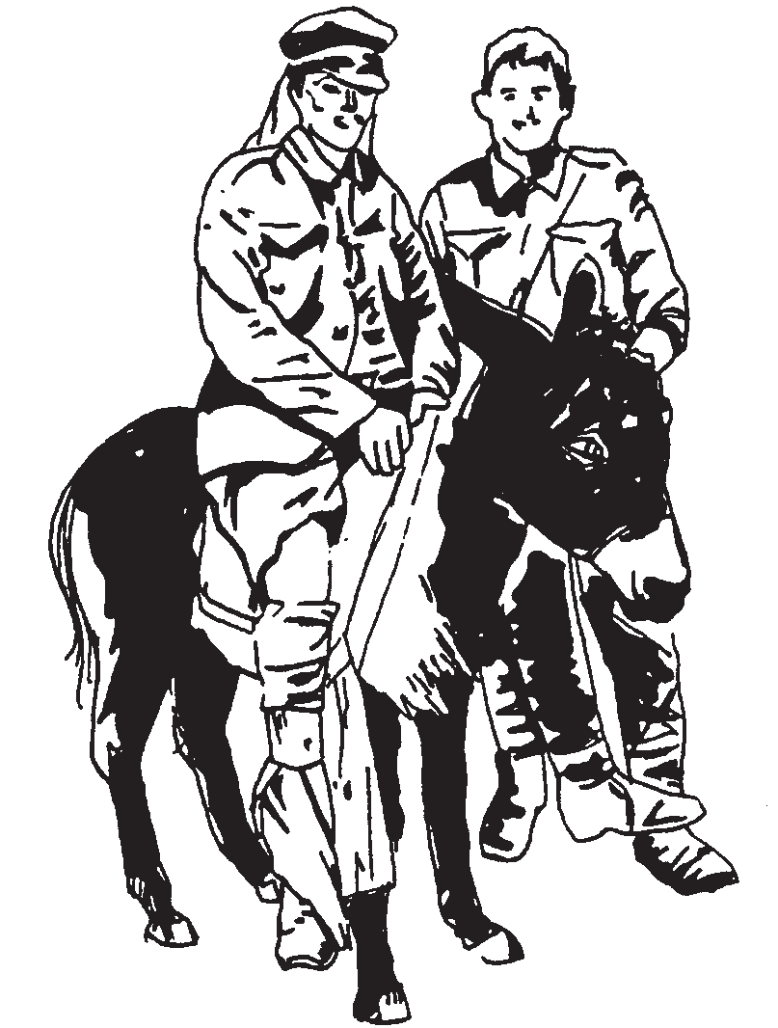
ANZAC DAY
Help Simpson and his donkey find
their way to the medical tent.

I think John Simpson was

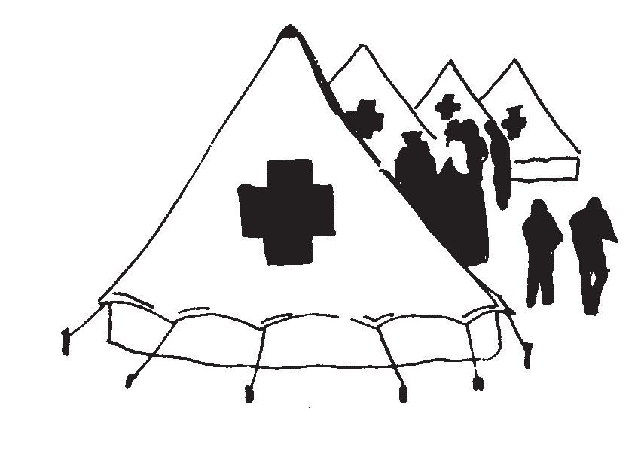

Name:

