~ Excel 2010 Skills for Graphs and Displays ~
Tables  frequency /tally table | Year level in  Australian curriculum | Example of Chart | Excel Skills  Note all instructions assume as sample size of 100 with a heading row in a1
Frequency table  For categorical or discrete numerical data | 2, 3, 4, 5, 6 | Type of Travel to School  tally frequency  car llll llll llll llll llll llll llll llll llll lll 48  walk llll llll llll llll l 21  bus llll llll llll llll 20  boat/ferry l 1  bicycle llll 4  skateboard etc ll 2  TOTAL 96 | FREQUENCY TABLE 1  1. Select method of travel to school, copy and  paste into a new worksheet starting at a1.  2. Starting in a blank cell type the names of the  different transport types down the page.  3. In the frequency column in the cell next to  car type the formula =countif(a2:a101,”car”)  4. Continue for each other variable, using the  same range. Make sure the variable is in  quotation marks and note that it is case  sensitive.  5. Tally marks are formed with a 1 and strike  through from the font menu in the Home tab.  6. Finish with a border by first selecting the table  cells.  In the Home tab go to Paragraph, select  then Borders and Shading to format  your table.  GROUPED FREQUENCY TABLE 2  1. Follow steps 1 & 2 above to set up a table after  choosing an appropriate interval (eg 10 cm)  2. Order your data by first selecting it. In the  Data tab under Sort and Filter and select Sort.  3. You now need to count the frequency of the  data in each of your intervals and add this to  the frequency table.  4. Follow steps 5. and 6. Above to finish.
Grouped frequency table  For numerical data | (not specified) | Height of Students  Height (cm) tally frequency  190 > 200 0  180 > 190 ll 2  170 > 180 llll 4  160 > 170 llll llll llll 15  150 > 160 llll llll llll llll llll llll lll 33  140 > 150 llll llll llll llll llll llll ll 32  130 > 140 llll llll 10  TOTAL 96
Picture graphs pictographs | Year level | Example of Chart | Excel Skills
One to one correspondence  Mainly used for categorical data | 2, 3 | 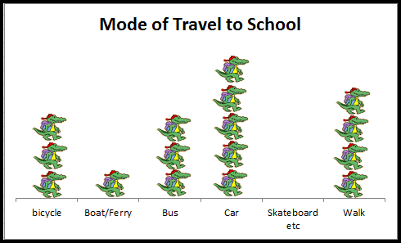 | PICTURE GRAPH 1  1. Using Table 1, select type of travel and  Frequency. Hint, use the Ctrl key to select non  adjacent columns.  2. From the Insert tab select Column and then  the first column graph.  3. Double click on any column to select it.  4. Right click and select ‘Format Data Point’.  5. Select ‘Fill’ then ‘Picture or texture Fill’...  6. From the Insert tab, choose Clip Art and select  your picture by double clicking it.  7. Change the scale by double clicking then right  clicking. Choose ‘Format data Point’ then Fill  and choose Stack and Scale with 1  8. Repeat for the other columns  PICTURE GRAPH 2  Follow steps 1 – 7 but choose ‘Stack and Scale  with....’ 5 or appropriate number of units.  .
Many to one correspondence  Mainly used for categorical data | 4, 6 | 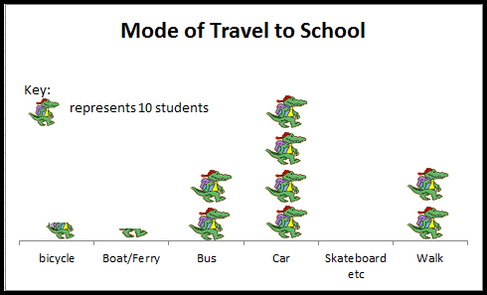
Bar Graphs  vertical/column or horizontal bar | Year level | Example of Chart | Excel Skills
Bar chart  Used for categorical and discrete numerical data  Horizontal bar chart Useful when the category names are long | 3, 4, 5 | 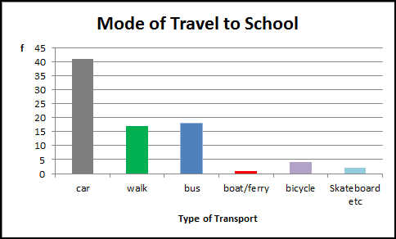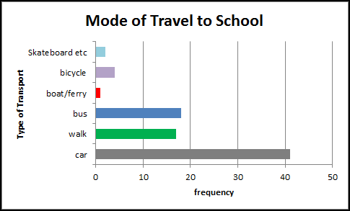 | BAR GRAPH 1  1. Follow steps 1 – 3 in Picture Graph 1 above.  2. In the Layout tab choose Chart title and then Axis title to label your graph.  3. Change the colour of the bars by clicking on the bars to select all, and then clicking on one bar. Go to Format and choose Shape Fill.  HORIZONTAL BAR GRAPH 2  1. As above but choose bar and not column graph in the Insert tab.  SIDE BY SIDE COLUMN GRAPH 3  1. Make sure you have a frequency table set up with 2 attributes e.g. male and female.  2. Follow steps 1 – 3 above. Note choosing the first bar chart type will give a side by side bar chart if the information is correctly set out in the frequency table.  STACKED BAR CHART 4  1. Make sure you have a frequency table set up with at least 2 attributes expressed as percentages.  2. Follow steps above and choose the second (for percentage frequency) or third (to convert to a % frequency) bar chart type from the Chart menu.
Side by side column Graphs 2 or more attributes for each variable | 6 | 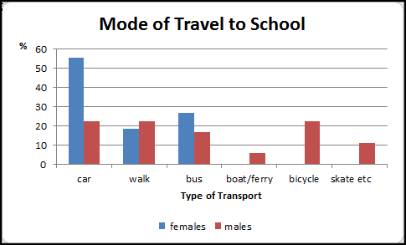
Stacked bar chart  For 2 or more attributes compared among 2 or more categories | (not specified) | 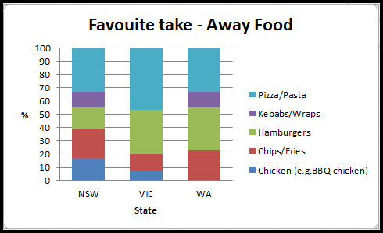
Dot Plots | Year level | Example of Chart | Excel Skills
One to one correspondence  Used for categorical and discrete numerical data. | 5, 7  10  Compare shapes of boxplots to correspond-ing histograms and dot plots | 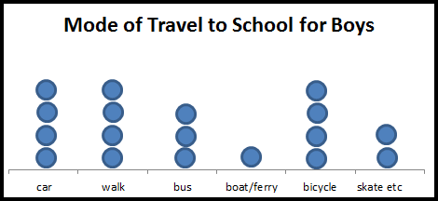 | DOT PLOT 1  1. Follow steps for Picture Graph 1 above.  2. From the Insert tab select Shape and then oval  to create and insert a circle in place of the  picture.  DOT PLOT 2  1. Follow steps for Picture Graph 2 above.  2. From the Insert tab select Shape and then oval  to create and insert a circle in place of the
Many to one correspondence  Used for categorical and discrete numerical data.  NB Can use crosses etc. | 6 | 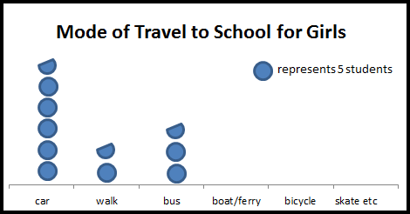
Pie Graphs | Year level | Example of Chart | Excel Skills
Used for categorical and discrete numerical data | (6 Elaboration) | NOTE: Yr 6 (Elaboration) “identifying potentially misleading data representations such as…pie charts in which the whole pie does not represent the entire population about which the claims are made”  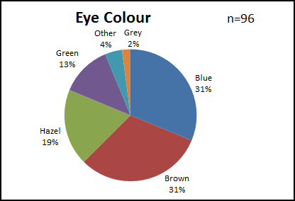 | PIE GRAPH  1. Create a frequency table.  2. From the Insert tab select the first Pie.  3. With the graph selected, go to the design tab  and select the label option you prefer.  4. Follow step 3 in Bar Graph 1 to change sector  colours.
Stem and Leaf Plots | Year level | Example of Chart | Excel Skills
Single  Used for discrete and continuous numerical data. | 7 | Belly button Heights  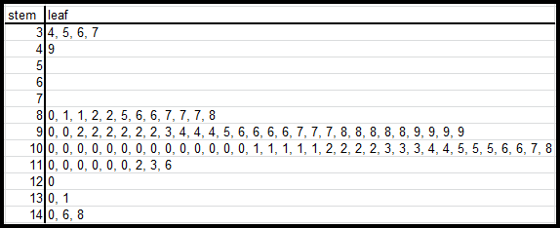  KEY 3|4 represents 34 | STEM AND LEAF PLOT 1 and 3  1. Order your data as shown in Table 2 step 2.  2. Create a frequency table as in Table 1. Ensure that the numbers in the leaves are set out evenly, separated by a comma and a space.  3. Remember to show the key.  BACK TO BACK STEM AND LEAF PLOT 2  As above.  Note: values in the left hand leaves show values ascending from right to left.
Back to back  Used for discrete and continuous numerical data. | 9  “Describe data using terms including ‘skewed’, ‘symmetric’, and  ‘bi modal’ ” | Belly button Heights  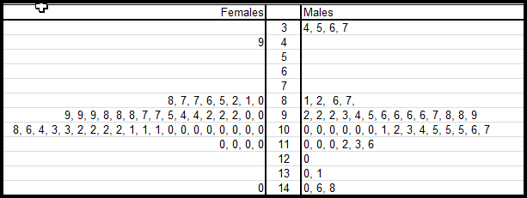  KEY 3|4 represents 34
Split stems  Used for discrete and continuous numerical data. | (not specified) | Dominant Hand Reaction Time  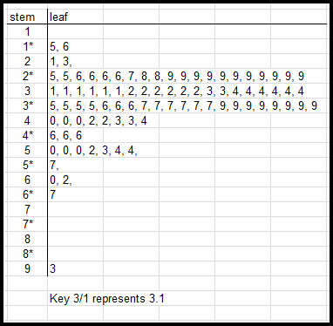
Histograms | Year level | Example of Chart | Excel Skills
Used for discrete numerical | 9  Describe data using terms including ‘skewed’, symmetric’, and  ‘bi modal’  10  Compare shapes of boxplots to correspond-ing histograms and dot plots |  | HISTOGRAM 1  1. Follow steps in Bar Chart 1.  2. Retain frequency bars only. Click on other bars  and delete.  3. Click on Series labels and delete.  4. In the Layout tab choose Chart title and then  Axis title to label your graph.  5. If necessary, Select the Design tab, Data, Select  Data. Under Horizontal (Category) Axis Labels,  select Edit.  6. From the frequency table select the range of  values to be shown on the horizontal axis.  Then OK.  7. Double click on the bars then slide the slider to  No Gap.  8. In the Format tab choose a contrasting outline  shape colour.  HISTOGRAM 2  1. Follow the steps above.  2. For grouped data, the interval labels need to  be placed below the axis marks. This is most  easily done by inserting a text box with the axis  labels.
Grouped numerical | (not specified) | 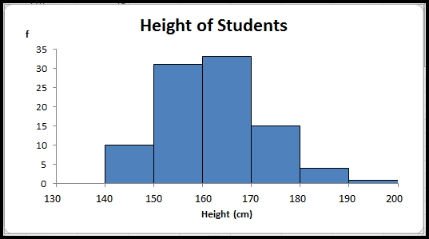
Box Plot  Box and whisker plot | Year level | Example of Chart | Excel Skills
Single box plot  Used for categorical and discrete numerical data. | 10  Compare shapes of boxplots to correspond-ing histograms and dot plots | 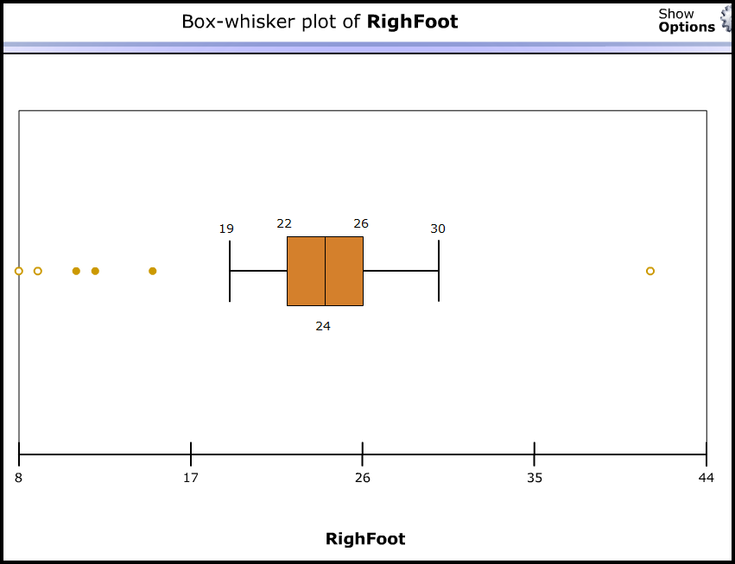 | BOX AND WHISKER PLOTS 1 & 2  Box and whisker plots not a standard chart type in Excel. The first plot was made using the International Data Tool (UK CensusAtSchool). There is a link to this tool on the ABS CensusAtSchool pages.  However, it is possible to use 'Scatterplots with straight lines' to create box plots by joining ordered pairs of coordinates. Calculated values of min, Q₁, med, Q₃ and max are used for the x axis while the y axis values specify vertical position.  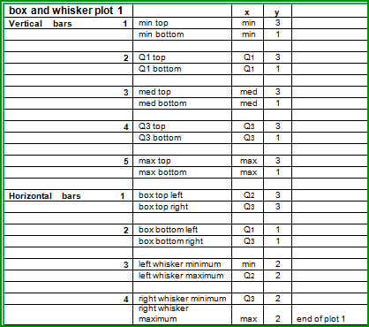  For parallel box and whisker plots repeat the details of any subsequent plot below the first one after leaving a one row gap. Increase the y values to allow new box plots to be drawn above the original.  The Education Services box and whisker plot tool uses this method to draw up to 5 parallel plots and identify possible outliers. Click on the link on the Education Services home page
Parallel box plots  Used to compare the distribution of two numerical data sets | 10 | 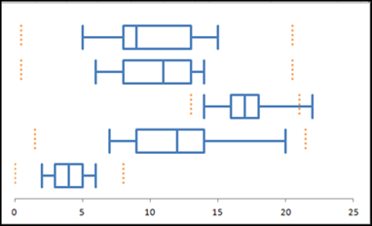
Scatter plots | Year level | Example of Chart | Excel Skills
A bivariate display for numerical data  Relationship can be negative or positive, weak, strong or none, linear or non linear | 10 | 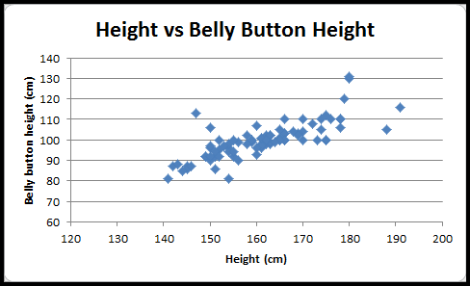 | SCATTER PLOT 1  1. Select the 2 data sets you are looking for a  relationship between.  2. In the Insert tab select the first Scatter plot.  3. To change the axis scale, from the Layout tab  choose Axis then Primary Axis then Primary  Horizontal Axis then More Primary Horizontal  Axis Options.  4. Choose appropriate Minimum, Maximum and  Major unit values  TIME SERIES SCATTER PLOT 2  (INDEPENDENT VARIABLE IS TIME)  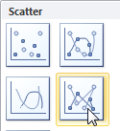  1. Select all data to be graphed including  headings.  2. From the Insert tab select  Scatter then  Scatter with Straight Line  and Markers.  3. Format line by first selecting it, then going to  the Format tab, selecting Shape Outline then  Weight.
Independent variable is time | 10 | 20 – 24 year olds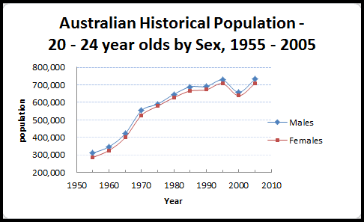
Straight line of best fit  (linear trend line) | 10A | 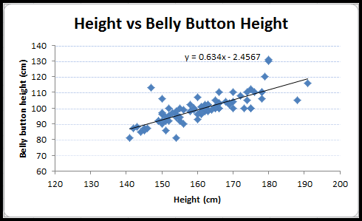  Belly button height = 0.634 x height + 2.457 cm | LINE OF BEST FIT SCATTER PLOT 3  1. Follow steps 1 – 4 for Scatter plot 1.  2. In the Format tab select Trend line and select  appropriate line option.  3. Tick the box to display trend line on the graph.
Summary statistics | Year level | Used for continuous and discrete numerical data | Excel Skills
- Measures of Centre: median, mean, mode  - Measures of Spread: range | 7  Includes “locating mean, median and range on graphs and connecting them to real life”) | Numerical:  - Median: Centre of ordered data  - Mean: sum of data divided by the number of data values  Categorical:  - Mode: most frequently occurring item  Numerical  - Range | Median  In an empty cell, type =median ( then select the data) Enter. e.g. =median(a2:a201)  Mean  In an empty cell, type =average ( then select the data) Enter.  Mode  In an empty cell, type =mode( then select the data) Enter.  Range  In an empty cell, type =max( then select the data)Enter - =min(then select the data)Enter.
- Outliers: effect on mean and median | 8
- Description of shape:  skewed, symmetric, bi modal | 9  10  Compare shapes of boxplots to correspond-ing histograms and dot plots | 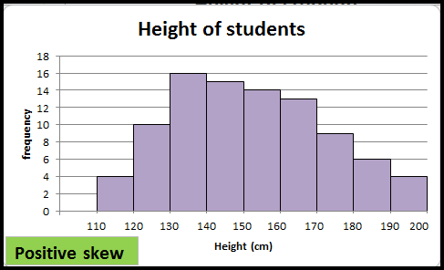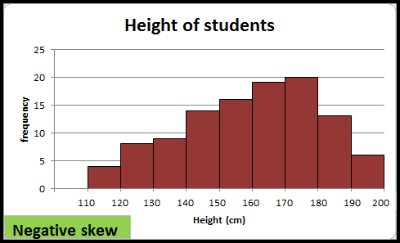  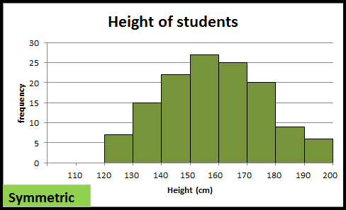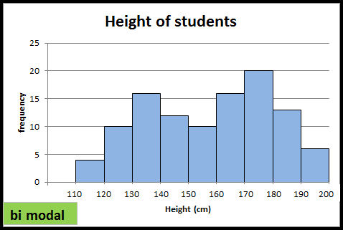
- Measures of Spread: range, interquartile range, 5 number summary | 10 | Numerical  - Range max – min  - Interquartile range (IQR)Q₃ – Q₁  - min, Q_{1,} median, Q3, max
- Measures of Spread: mean and standard deviation | 10A  interpret mean and standard deviation | For a normal distribution  68% of observed values fall within 1 standard deviation of the mean,  95% of observed values fall within 2 standard deviations of mean,  69.7% of observed values fall within 3 standard deviations of mean
Some general notes on making charts
Charts convey quick visual information about a distribution. This is more obvious when diagrams use a scale so comparative integrity can be assumed. Charts in 2D are more accurately read than those in 3D. Graphs should:
- always show chart title, axes labels and provide a key when necessary
- use a scale whenever possible
- be shown in 2D rather than 3D
Also:
- (Year 6 Elaboration) Beware of graphs that are “…potentially misleading …such as…with ‘broken’ axes, non-linear scales…”
- From Year 3 “Create displays….with and without the use of digital technologies”

Glossary Note: (A) indicates definition from the ACARA Glossary
Bar graph | A bar graph is used to show discrete data. It shows separate bars to represent the frequency of each category of data. The bars can be vertical  or horizontal. (A)
Categorical data | A categorical variable has two or more categories without any ordering. e.g. hair colour is a categorical variable because there is no ordered way  of describing hair colour. A purely categorical variable is one that simply allows you to assign categories but you cannot clearly order the  variables. (A) Note: where numbers represents a category e.g. Postcodes represent areas, they are classed as categorical data.
Column graph | Column graphs are used to show categories of data that has been counted. These categories consist of separate or discrete data. The horizontal  axis is marked in equal intervals and the vertical columns are also of equal interval size. They are used for comparing things. In a column graph,  the height of the column shows the number of individuals. Since the data is not related, the columns stand alone. (A)
Continuous data | Continuous data is data which can take any numerical value within certain restrictions. It is data which is not discrete. (e.g. height, time)
Data | Information collected for analysis or reference. (A)
Data display | A visual format for organising information (e.g. graphs, charts)
Dependent variable | A dependent variable is one whose value depends on the value of another variable. (A) e.g. height depends on age
Discrete data | Separate data(A) Data that can only take particular values (e.g. shoe size, number of eggs)
Distribution | The pattern of variation of a variable
Dot plot | A dot plot is a chart where each data point is represented as a dot. (A)
Independent  variable | An independent variable is one whose value does not depend on the value of another variable e.g. height depends on time
Mean | The mean of a set of numbers can be calculated by summing all the values and dividing by the number of values. (A)
Median | The median of a set of values is the middle value when all values are arranged in numerical order. E.g. for the set {13, 23, 11, 16, 15, 10, 26} written in  order {10, 11, 13, 15, 16, 23, 26} the median is 15. If there is an even number of data values the median is the average of the two middle values. (A)
Mode | The mode value of a data set is the most commonly occurring value. (A)
Numerical data | Can be discrete, data can take specified values only; or continuous, data can take any value within a range. Also see note above in ‘Categorical data’
Picture graph | A graph that use pictures to represent the frequency of the data in each category. Each symbol can represent one piece of data or more than  one piece of data. (A)
Stem and leaf plots | Stem and leaf plots are a table where discrete data is represented (usually in order) by distinguishing values (the leaf) within set intervals (the  stem) (e.g. the set of students’ height in cms……XXX…. Key: 15|2 = 152 cms Stem plots provide a visual indication of spread. (A)
Univariate data | Data that has only one variable is called univariate data. (A)
Variable | Any characteristic of a person or thing

